Precisionism 498 Words

Precisionism was a modernist art movement during the 1920s and 1930s in the United States in which painters produced a “machine aesthetic” by rendering precise, geometrical forms in their works. A group of American painters that were originally called “The Immaculates,” the Precisionists celebrated the new industrial landscape of skyscrapers, factories, bridges, and other mechanized phenomena. Although never a formalized “school” and working without a manifesto, Precisionism reflected both the exciting dynamism of the ‘Roaring Twenties’ as well as the streamlined simplicity of the Great Depression. Their images produced an ambivalent attitude toward mechanisation, at once praising its efficiency and condemning its dehumanisation. Appearing immediately after a host of other influential modernist movements such as Cubism and Futurism, Precisionists merged the impulse toward abstraction with a photographically realistic eye. While no artist worked exclusively as a Precisionist, there were several for whom it was a formative style. Perhaps the most prolific artists who produced Precisionist works were Charles Sheeler, Charles Demuth, and Georgia O’Keeffe. Together, these three painters and several others created a distinctly American brand of imagery that was a celebration of nationhood as much as a celebration of mechanization.

At its core, Precisionism was the logical extension of the modernist movement in America that had been developing since the New York Armory Show in 1913. When Marcel Duchamp debuted his “Nude Descending a Staircase,” it ushered in a new paradigm for artists, one that glorified the machine with almost divine reverence. As early as 1917, Sheeler and Demuth began producing works that showed a severity of subject matter as well as style. Coming off the heels of the chaos of World War I, many art historians believe that the Precisionists emerged out of the desire for a return to order, and during the 1920s Precisionist works were displayed in galleries all around New York. Reflecting the abstraction of the patterns of urban geometry, these works portrayed unknown and anonymous views of the sides of skyscrapers, large industrial plants like the River Rouge in Detroit, and severe views of new steel bridges such as the George Washington and Queensborough in New York. However, it would be misleading to characterize Precisionism as exclusively urban. In fact, works like Demuth’s “My Egypt” (1927) and Sheeler’s “Americana” (1931) celebrated the vernacular and the specificity of American rural material culture. Particularly in the late 1920s and early 1930s, when the grips of the Great Depression began to shift the United States away from its affinity for urbanism, Precisionist painters also found rejuvenated national spirit in the grain silos and handmade craftsmanship of country life.

References and further reading

Friedman, M. (1960) The Precisionist View in American Art. Exhibition Catalogue. Minneapolis: Walker Art Center.

Harris, E., et al. (1994) Precisionism in America, 1915-1941: Reordering Reality. Exhibition Catalogue. New York: Abrams.

Lucic, K. (1991) Charles Sheeler and the Cult of the Machine. Cambridge, MA: Harvard University Press.

Tsujimoto, K. (1982) Images of America: Precisionist Painting and Modern Photography. Seattle: University of Washington Press.

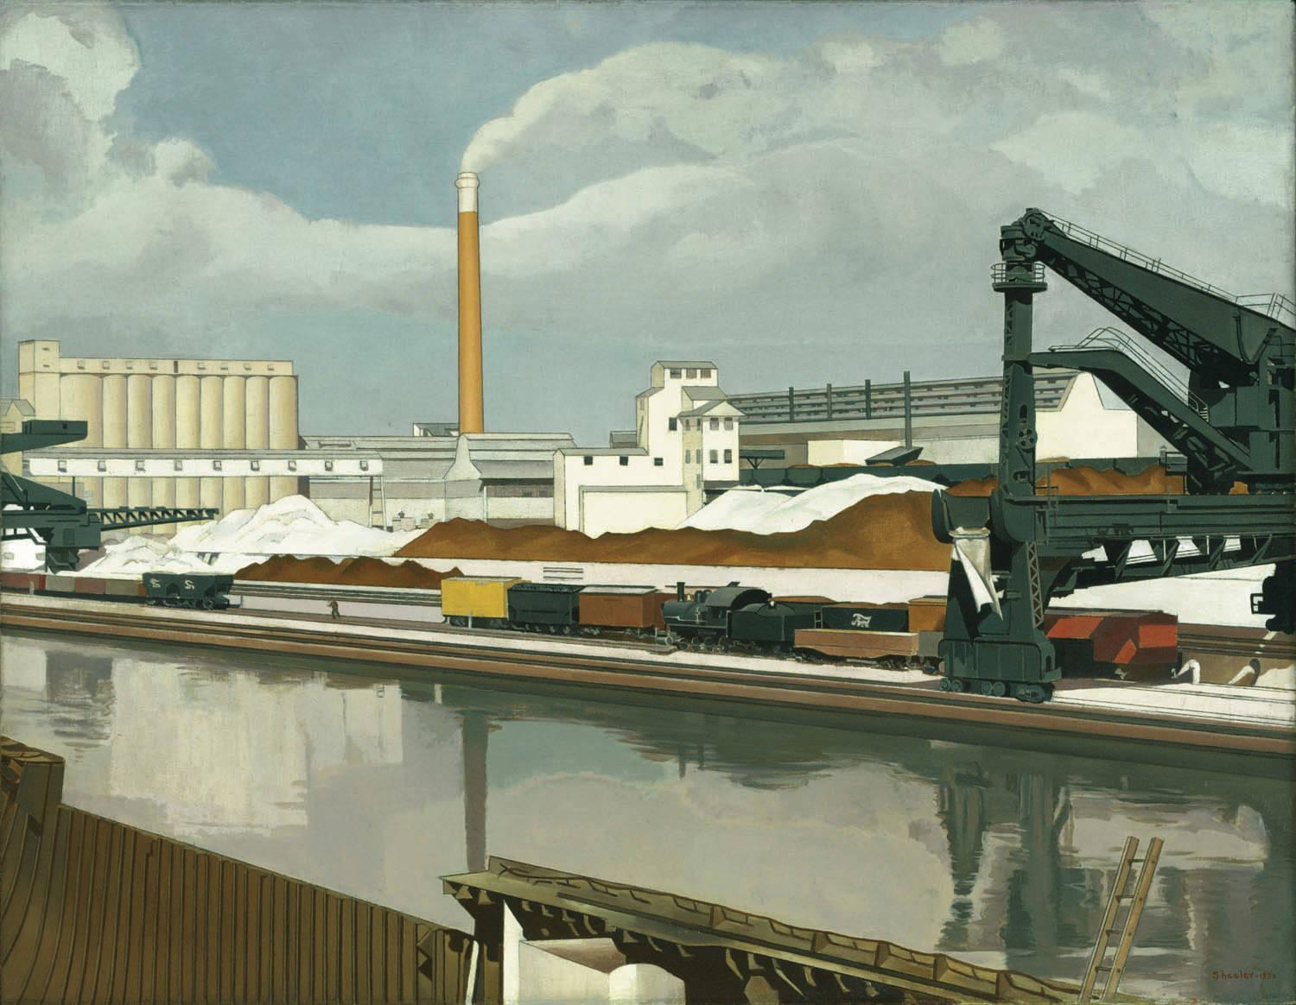

Charles Sheeler
American Landscape
1930
Oil on canvas
61 x 78.8cm
Museum of Modern Art
New York

http://www.moma.org/collection_images/resized/086/w500h420/CRI_157086.jpg

